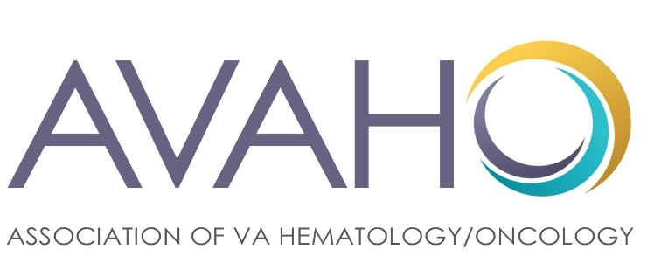
AVAHO 2020 VIRTUAL MEETING EXHIBITOR + MARKETING OPPORTUNITIES
Updated prospectus addendum for Virtual Format

Please contact Julie Lawson (314-853-6063 or execdirector@avaho.org) or Sue Lentz (206-794-9124 or admin@avaho.org) to make sponsor level selections, ask questions and/or arrange for payment.

Technology Sponsor - $75,000
As a virtual event, AVAHO is teaming up with a technology partner (to be named by June 10, 2020) to host our online meeting platform. This opportunity includes a platinum sponsorship and naming rights (i.e., “AVAHO Virtual Meeting Platform brought to you by XX” or “XX Virtual Platform”). This is available to one company only and will be granted on a first-committal basis.

Platinum Sponsor Benefits - $50,000+
The 2020 Virtual Platinum benefits include:
- Top billing placement (top of site, largest icons) of booth in virtual exhibitor hall
- Free inclusion of printed, branded materials (hard copy up to four ounces) in the conference package mailed to all registrants (500+)
- 10 free admissions to the virtual conference ($300 value each)
- Live conferencing ability with participants on 9/12 and 9/13
- Two 3-minute videos posted within your virtual booth (in addition to 10 clickable information links and images)
- Emailed information: an email of resources relevant to practitioners will go out each day between 9/12 and 9/19 that will include sponsor-related information
- Banner ad on conference website
- Logo display on all printed conference collateral and emails to members
- Banner ad on AVAHO website for 6 months (beginning 10/1/20)
- Two social media blasts (Facebook and Twitter)
- Sponsored panel discussion to be held virtually between 9/20/20 and 12/31/20

Gold Sponsor Benefits – $30,000
The 2020 Virtual Gold benefits include:
- Secondary (just below platinum) exhibitor hall booth placement and logo placement
- 8 admissions to the virtual conference ($300 value each)
- Live conferencing ability with participants on 9/12 and 9/13
- One 3-minute video posted within virtual booth (in addition to up to 6 clickable information links and images)
- Emailed information: an email of resources relevant to practitioners will go out each day between 9/12 and 9/19 that will include sponsor related materials
- Banner ad on conference website
- Banner ad on AVAHO website for 90 days (beginning 10/1/20)
- Two social media blasts (Facebook and Twitter)

Silver Sponsor Benefits - $15,000
The 2020 Virtual Silver Sponsor benefits include:
- 3rd-tier placement of booth in virtual exhibitor hall and prominent logo placement
- 6 admissions to the virtual conference ($300 value each)
- Live conferencing ability with participants on 9/12 and 9/13
- One 2-minute video posted within virtual booth (in addition to 3 clickable information links and images) and four (4) clickable ads
- Small banner ad on conference website
- Banner ad on AVAHO website for 30 days (beginning 10/1/20)

Bronze Sponsor Benefits - $2,500
The 2020 Virtual Bronze Sponsor benefits include:
- Booth in virtual exhibitor hall
- 4 admissions to the virtual conference ($300 value each)
- Clickable ads (2) and information within virtual exhibitor hall booth
- Logo recognition on conference website

Virtual Exhibitor - $1,000
Your company or product listed within the virtual exhibit hall with a clickable link through to your company’s (or product’s) site.

Additional Opportunities

Virtual 5K Sponsor - $2,500
This is an additional charge to any sponsorship package but will count towards your overall sponsorship level.

In 2020 we are holding our first Virtual 5K Fun Walk/Run to benefit the AVAHO Foundation (the Foundation, formed in 2020, will fund Veteran cancer research efforts and support Veteran-focused organizations in times of need). This virtual event will include a t-shirt with your logo (mailed to each participant) as well as live-feed social media coverage of runners all over the country where we will consistently mention our sponsors. We encourage company representatives to join us in the run, too!
Registration Package Inserts ($3,000):
Exhibitors may provide important literature to each conference attendee in a mailed package that will be sent to all conference participants who register by August 31, 2020. All materials must be approved by AVAHO in advance. Pricing is based on maximum four pages or four ounce insert; premium charges may apply if exceeded.
Educational Grants: $15,000 - $100,000+
AVAHO accepts educational and in-kind support from corporations, foundations and other organizations that do not pose a conflict of interest to AVAHO or VA employees. Grants may be used to support CE-accredited training. Please contact AVAHO for more information.

